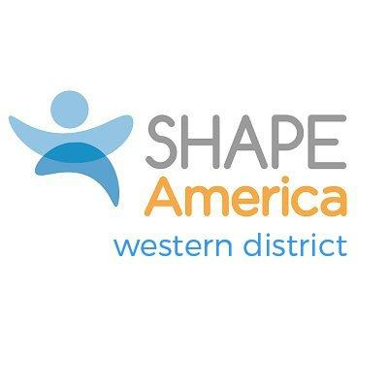
Western District College/University
Teacher of the Year Award:

Any SHAPE America member who resides in the Western District (WD) may nominate candidates for the College/University Teacher of the Year Award. This award honors a college/university professional in the health, physical education, adaptive physical education, or dance pedagogy.
The award can be given annually at a SHAPE Regional conference or workshop sponsored or co-sponsored by Western District, or at the state conference of the candidate usually August-October of each year. The deadline for nominations is September 15. The deadline for applications is October 15. The qualifying criterion for this award includes:

- SHAPE America Membership: The nominee shall have been a member of SHAPE America for a minimum of 3 years, including the year he/she is considered for the award.

- Character: Ethical behavior consistent with the accepted ideals of the profession.

- Service:
- Candidates must have five years of experience at the college/university level;
- Each candidate must demonstrate at least three of the specific contributions criteria as follows:
  - Position of leadership in developing and implementing or directing/coordinating effective health/physical education/ adaptive physical education/dance promotion programs;
  - A record of outstanding teaching effectiveness in and out of the classroom (including mentoring undergraduate or graduate students);
  - A pedagogical approach that is new, creative or innovative but still intellectually rigorous;
  - Meritorious service through involvement at local, state, district or national level or at the school or community level;
  - Service within a SHAPE America structure or other professional organizations at the state, district or national level as an officer or committee member;
  - Evidence of other leadership and service to the profession through teaching, publications, presentations, funded research or programs, special projects, or health-related activities.

Western District College/University Teacher of the Year Award
Candidate Application (Health, PE, Adaptive PE or Dance)
Nominations are due by September 15
Applications are due by October 15
Return to District Awards Chair: See SHAPE America Western District webpage

Indicate award category: ___Health ___PE ___APE ___Dance

Name of candidate:

College/University Organizational head contact information:

Local media outlet contact information:

Criteria: Membership- Must be a SHAPE America Member for at least 5 years
SHAPE America membership number: __________________

Length of time as a SHAPE America member:____________

Other professional organizational membership(s) or certifications:

- Criteria: Character Provide two letters of support that speak to your character, service, leadership, and contributions to the profession.

- Criteria: Service –Please provide at least 3 written examples from the following criteria:
  - Position of leadership in developing and implementing or directing/coordinating effective health/physical education/ adaptive physical education/dance promotion programs;
  - A record of outstanding teaching effectiveness in and out of the classroom (including mentoring undergraduate or graduate students);
  - A pedagogical approach that is new, creative, or innovative but still intellectually rigorous;
  - Meritorious service through involvement at local, state, district, or national level or at the school or community level;
  - Service within a SHAPE America structure or other professional organizations at the state, district, or national level as an officer or committee member;
  - Evidence of other leadership and service to the profession through teaching, publications, presentations, funded research or programs, special projects, or health-related activities.

